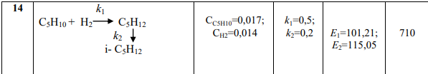

A + B -> C -> D

R1 = k1 \* C(A) \* C(B)

R2 = k2 \* C(C)

$$\left\{\begin{aligned}\frac{dC_{A}}{dt}=-R1 \\ \frac{dC_{B}}{dt}=-R1 \\ \frac{dC_{C}}{dt}=R1-R2 \\ \frac{dC_{D}}{dt}=R2\end{aligned}\right.$$

$$\left\{\begin{aligned}C_{A}^{n+1}=C_{A}^{n}+Δt(-{(k}_{1}*C_{A}*C_{B})) \\ C_{B}^{n+1}=C_{B}^{n}+Δt((-k_{1}*C_{A}*C_{B})) \\ C_{C}^{n+1}=C_{C}^{n}+Δt\left(\left(k_{1}*C_{A}*C_{B}\right)-\left(k_{2}*C_{C}\right)\right) \\ C_{D}^{n+1}=C_{D}^{n}+(k_{2}*C_{C})\end{aligned}\right.$$